**West Bengal**

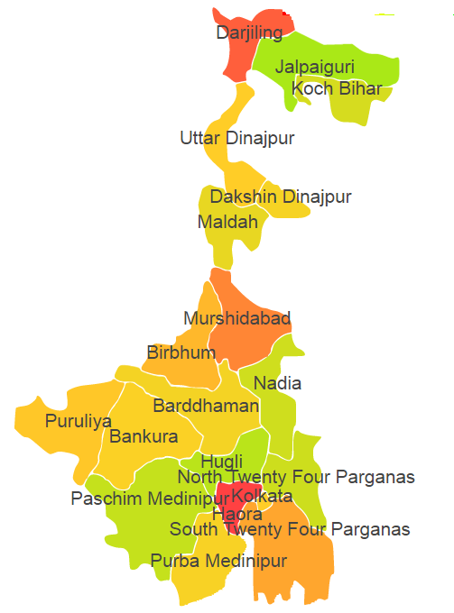

West Bengal comprises of four Agro Ecological Regions (AER) 12,15,16 & 18.

**Agro-Eco Region 12:** AER 12 in West Bengal comprises of Bankura, Bardaman, Birhum, Pashchim Medinipur and Puruliya districts of Eastern (Chhotanagpnr) Plateau and Eastern Ghats under Agro Ecological Sub Region (AESR) 12.3.

**Agro-Eco Region 15:** AER 15 in West Bengal comprises of Bankura, Bardaman, Birhum, Dakshin Dinajpur, Haora, Hugli, Jalpaiguri, Malda, Mursidabad, Nadia, North 24 Pragana, Pashchim Medinipur, Kochbihar, South 24 Parganas and Uttar_Dinajpur districts of Bengal and Assam Plain under Agro Ecological Sub Regions (AESR) 15.1 & 15.3.

**Agro-Eco Region 16:** AER 16 in West Bengal comprises of only one Darjeeling district of Eastern Himalayas under Agro Ecological Sub Region (AESR) 16.2.

**Agro-Eco Region 18:** AER 18 in West Bengal comprises of East mednipur and South 24 Parganas districts of Eastern Coastal Plain under Agro Ecological Sub Region (AESR) 18.5.

**Major NRM issues :**

**AESR 12.3:** The region is hot dry subhumid ESR with moderately deep to deep loamy to clayey Red and Lateritic soils, medium AWC and LGP of 150-180 days in a year.

|  |  |  |  |  |
| --- | --- | --- | --- | --- |
| **Districts** | ***Land degradation*** | ***Soil health & fertility*** | ***Water related constraints*** | ***Environmental constraints*** |
| Bankura | Exclusively water erosion | Soil deficient in N, B & S | Saline GW Contaminated with F, NO3 & Fe | **-** |
| Bardaman | Exclusively water erosion | Soil deficient in K | GW Contaminated with NO3, As & Fe | Moderately prone to Flood |
| Birhum | Exclusively water erosion | Low in OC, Soil deficient in N & S | GW Contaminated with F, NO3 & Fe | **-** |
| Pashchim Medinipur | Exclusively water erosion | Soil deficient in N, Fe, B & S | GW Contaminated with Fe | Highly prone to Flood & Cyclone |
| Puruliya | Exclusively water erosion | Low in OC, Soil deficient in N, Mn, B & S | Saline GW Contaminated with F & Fe | **-** |

**AESR 15.1:** The region hot moist subhumid ESR with deep loamy to clayey alluvium-derived soils, medium to high AWC and LGP 210-240 days in a year.

|  |  |  |  |  |
| --- | --- | --- | --- | --- |
| **Districts** | ***Land degradation*** | ***Soil health & fertility*** | ***Water related constraints*** | ***Environmental constraints*** |
| Bankura | Exclusively water erosion | Soil deficient in B & S | Saline GW Contaminated with F, NO3 & Fe | **-** |
| Bardaman | Exclusively water erosion | Soil deficient in K | GW Contaminated with NO3, As & Fe | Moderately prone to Flood |
| Birhum | Exclusively water erosion | Low in OC, Soil deficient in N & S | GW Contaminated with F, NO3 & Fe | **-** |
| Dakshin Dinajpur | - | Soil deficient in N, B & S | GW Contaminated with F & Fe | **-** |
| Haora | Coastal Salinity | Soil deficient in P & B | Saline GW Contaminated with As & Fe | **-** |
| Hugli | - | **-** | Saline GW Contaminated with Fe | Moderately prone to Flood |
| Malda | Waterlogged | Low in OC, Soil deficient in N | GW Contaminated with F, As & heavy metals | Moderately prone to Flood |
| Mursidabad | - | Soil deficient in Zn & B | GW Contaminated with NO3, As & heavy metals | **-** |
| Nadia | - | Low in OC & Soil deficient in S | GW Contaminated with F, As & heavy metals | Moderately prone to Flood |
| North 24 Pragana | Coastal Salinity | Low in OC, Soil deficient in N, Zn, B & S | Saline GW Contaminated with As, Fe & heavy metals | Highly prone to Flood & Cyclone |
| Pashchim Medinipur | Exclusively water erosion | Soil deficient in Fe, B & S | GW Contaminated with Fe | Highly prone to Flood & Cyclone |
| South 24 Parganas | Exclusively saline soils | Soil deficient in B | Saline GW Contaminated with F, As, Fe & heavy metals | **-** |
| Uttar_Dinajpur | Exclusively saline soils | Soil deficient in N, Mn & S | GW Contaminated with F & Fe | **-** |

**AESR 15.3:** The region is hot moist humid to perhumid ESR with deep, loamy to clayey alluvium derived soils, medium AWC and LGP 270-300 days in a year.

|  |  |  |  |  |
| --- | --- | --- | --- | --- |
| **Districts** | ***Land degradation*** | ***Soil health & fertility*** | ***Water related constraints*** | ***Environmental constraints*** |
| Jalpaiguri | Exclusively water erosion | Soil deficient in N, B & S | GW Contaminated with Fe | Moderately prone to Flood |
| Kochbihar | Exclusively water erosion & Exclusively acid soils | Soil deficient in N, K, B & S | GW Contaminated with As | **-** |

**AESR 16.2:** The region is warm perhumid ESR with shallow to medium deep loamy Brown and Red Hill soils, low to medium AWC and LGP 300 days in a year.

|  |  |  |  |  |
| --- | --- | --- | --- | --- |
| **Districts** | ***Land degradation*** | ***Soil health & fertility*** | ***Water related constraints*** | ***Environmental constraints*** |
| Darjeeling | Acid soils under water erosion | Soil deficient in N, B & S | - | Highly prone to Flood |

**AESR 18.5:** The region is hot moist subhumid to humid ESR with deep, loamy to clayey Coastal and deltaic alluvium-derived soils, medium AWC and LGP 240-270 days in a year.

|  |  |  |  |  |
| --- | --- | --- | --- | --- |
| **Districts** | ***Land degradation*** | ***Soil health & fertility*** | ***Water related constraints*** | ***Environmental constraints*** |
| East Mednipur | Coastal Salinity | Low in OC, Soil deficient in N, Zn, B & S | Saline | **-** |
| South 24 Parganas | Exclusively saline soils | Soil deficient in B | Saline GW Contaminated with F, As, Fe & heavy metals | **-** |

**Organization and Establishments for Technology Backstopping**

***ICAR Research Institutes/KVKs:***

|  |  |
| --- | --- |
| Regional Station of Central Soil Salinity Research Institute, canning-town | <https://cssri.res.in/canning-town-rrs/> |
| Regional Station of National Bureau of Soil Survey & Land Use Planning, Kilkata | <https://nbsslup.icar.gov.in/kolkata> |
| KVK Portal | <https://kvk.icar.gov.in/> |

***SAUs/CAUs:***

|  |  |
| --- | --- |
| Bidhan Chandra Krishi Viswavidyalaya, Mohanpur, Nadia, | <https://www.bckv.edu.in/index.php/en/> |
| Uttar Banga Krishi Vishwavidyalaya, Pundibari , Cooch Behar, | <https://www.ubkv.ac.in/> |

***List of KVKs:*** <https://icar.org.in/content/west-bengal>

***List of Soil testing Laboratories****:* [*https://farmer.gov.in/STLDetails.aspx?State=19*](https://farmer.gov.in/STLDetails.aspx?State=19)